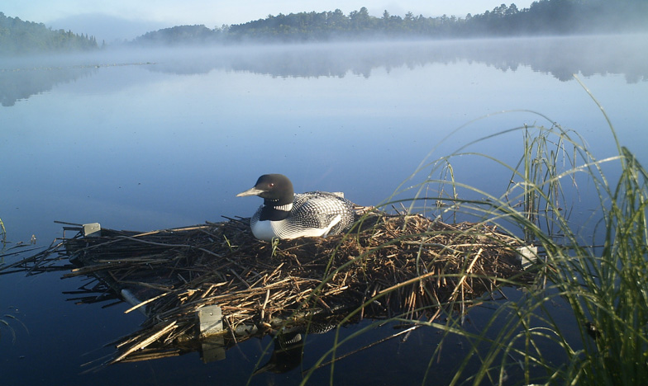

This photo is in a text box – feel free to delete the text box if you don’t want a photo. You can move this box around, too.

Insert your text here – you can make two columns in the text box if you’d like.

**You can also have a subheader like this.**

**Title Goes Here**