Faculty Guide for Wait Lists

# How to view your class wait list

1. Log into the your Minnesota State Employee Home.
2. Click the Faculty application.
3. Click “Wait List Report” 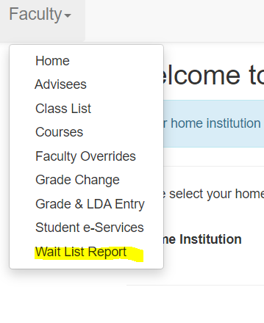
4. The report search field will automatically include your name. You can filter by a certain term/subject if you wish. Or click search to view all of your courses.

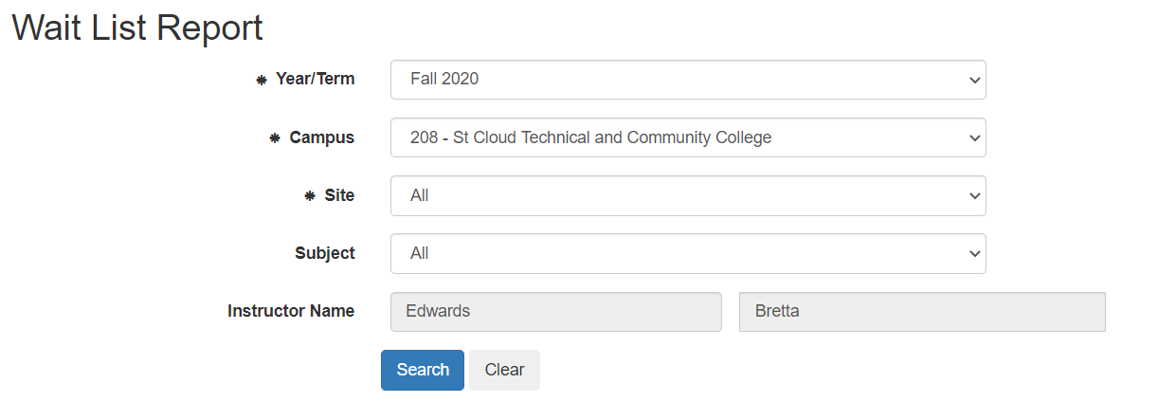

1. The total number of students enrolled an on your waitlist will display. To view the names of the students on the waitlist click the “Course ID” field.
2. The names and contact information for the students will display.

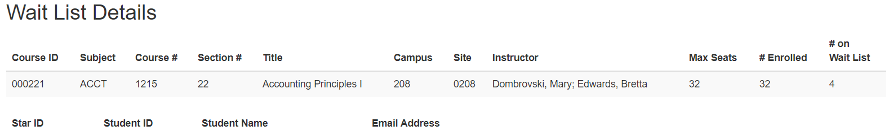

1. You can export to excel or print a copy if you wish.

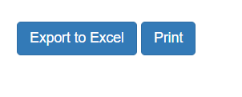

# Wait list Information

How it works – helpful hints

Here is the information with all of the details for exactly how students get on the waitlist, how it functions, and other helpful information: <https://www.sctcc.edu/sites/default/files/admissions/documents/Student%20Wait%20List.pdf>

How long is the wait list on/active?

The waitlist is active until 11:59 pm the day prior to the semester starting.

For example, Fall 2020 starts on Monday, August 24th, therefore the waitlist is active until Sunday, August 23rd until 11:59 pm.

The waitlist is off for the first week of classes, and then turned on again for courses that begin later in the semester.

Overloads and waitlists – must honor the wait list while it is active

Per MSCF contract, faculty may allow up to 2 additional students to register per course. This is completely at faculty discretion, and faculty are not obligated to do so.

Faculty often choose to honor requests for overloads based on the order of the waitlist, which is also at faculty discretion. Faculty are not obligated to follow the waitlist order.

For *how* to overload a student, see the Faculty Guide to Overrides.

**PLEASE NOTE:** While the waitlist is active, requests for overloads cannot be processed. We must honor the order of the waitlist while it is active. We cannot manually bypass the wait list order.

**Questions? Call us in Records and Registration at 320-308-5075**

Lisa Miller, Registrar 320-308-6521 [lmiller@sctcc.edu](mailto:lmiller@sctcc.edu) LM 3/12/2024